# Power Edge Specs

[Power Edge R710](https://www.itcreations.com/dell/dell-poweredge-r710-server?srsltid=AfmBOopiuocmKpkZ2reUJbVo480PnP2ThB9QjnACoX9cHaCPtlcaV0OC) x 2:

* CPU: 2
* Cores: 16
* Disks: 4 x 2.65GB
  + 4 x RAID5
  + description: RAID bus controller, product: MegaRAID SAS 1078
  + description: SCSI Disk, size: 836GiB (898GB)

[Power Edge R730](https://savemyserver.com/dell-r730-tech-specs/?srsltid=AfmBOoq8wDtU_b4yGmLakQAp__Z7qTNVaCr7XTUl8EMeCvr2kWod4BQb):

* CPU: 2
* Cores: 40
* Disks: 8 x 3.6TB
  + 1 x RAID0, 7 x RAID5

**Total**

* CPU: 6
* Cores: 72
* Disks: 8 x 2.65GB, 8 x 3.6TB
* Network: 12 ports

|  |  |  |  |  |
| --- | --- | --- | --- | --- |
| **Name** | **Virtual cores** | **Memory** | **Disk** | **Ephemeral** |
| m1.tiny | 1 | 512 MB | 1 GB | 0 GB |
| m1.small | 1 | 2 GB | 10 GB | 20 GB |
| m1.medium | 2 | 4 GB | 10 GB | 40 GB |
| m1.large | 4 | 8 GB | 10 GB | 80 GB |
| m1.xlarge | 8 | 16 GB | 10 GB | 160 GB |

<https://people.csail.mit.edu/jon/openstack-ops/openstack-ops-manual.pdf>

# Example Node Spec Recommendations (Table 1.1)

**Controller – 710A with RAID 5**

* CPU: 2
* Cores: 12
* Memory: 32GB
* Disk: 2 x 300GB
* Network: 2 x 10G ports

**Compute – 730 with RAID 5**

* CPU: 2
* Cores: 12
* Memory: 128GB
* Disk: 2 X 600GB
* Network: 4 x 10G ports

**Storage – 730 with RAID 5**

* CPU: 2
* Cores: 12
* Memory: 64GB
* Disk: 2 x 500GB, 24 x 600GB
* Raid Controller: PERC H710P Integrated RAID Controller, 1 GB NV Cache
* Network: 2 x 10G ports

**Network – 710B with RAID 5**

* CPU: 1
* Cores: 6
* Memory: 32GB
* Disk: 2 x 500GB
* Network: 5 x 10G ports

**Total**

* CPU: 7 → 8
* Cores: 42 → 72
* Memory: 256GB →?
* Disk: 14.4GB → 28.8TB
* Network: 13 x 10G ports →12 ports

# 3 Node Architecture Figures

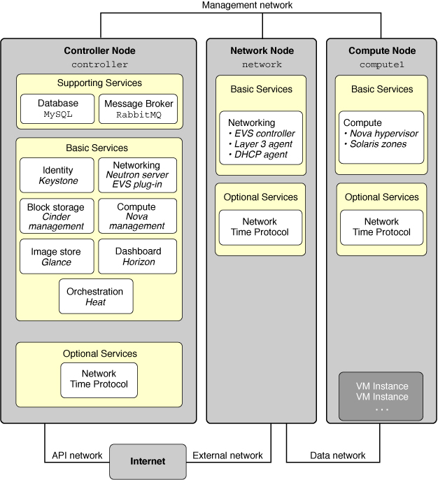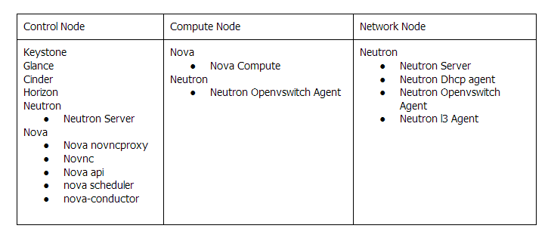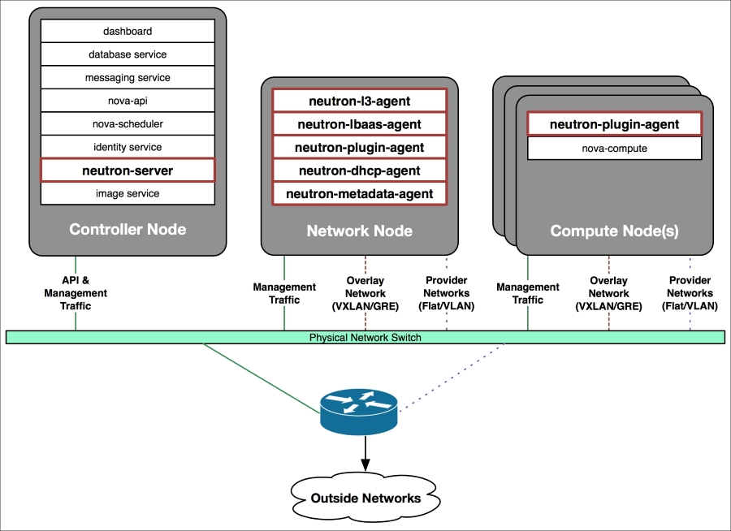

[Chapter 2. Recommended specifications | Red Hat Product Documentation](https://docs.redhat.com/en/documentation/red_hat_openstack_platform/10/html/recommendations_for_large_deployments/recommended-specifications#overcloud-compute-nodes)

[Three-Node Architecture Overview - Installing and Configuring OpenStack in Oracle® Solaris 11.2](https://docs.oracle.com/cd/E36784_01/html/E54155/archover.html)